## Problem E. Hills

In а sequence of numbers there are 4 types of regions: Hills, Plateaus, Marshes and Valleys. A **Hill** region is a number that has smaller numbers on both sides. A **Valley** region is a number which has bigger numbers on both sides. A **Plateau** is a subsequence of two or more equal numbers with smaller numbers at both ends of the subsequence. A **Marsh** is a subsequence of two or more equal numbers with larger numbers at both ends of the subsequence.

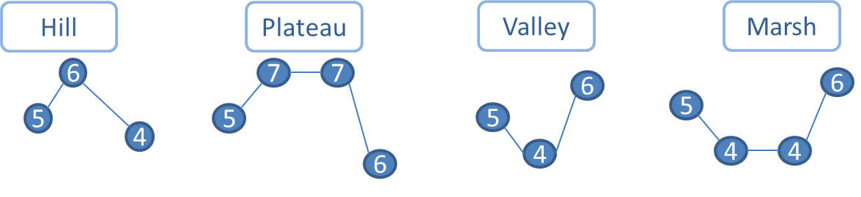

You are given a sequence of N integer numbers. Your task is to count all the Marshes, Plateaus, Hills and Valleys and print the result on the console. Note that the numbers in the sequence could form figures which are not any of the given regions (Hills, Plateaus, Marshes, Valleys and Borders). For example the figure below is neither Plateau nor Marsh and should not be counted.

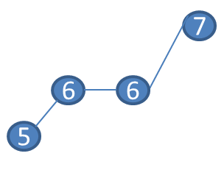

**Input**

The input is read from the console and consists of N tests (up to 100). At the first line a number N is entered. At the next N lines stays one of the tests – a sequence of integer numbers separated by spaces (up to 100 000).

**Output**

The output should be printed on the console and consists of N lines. Each line consists of 4 numbers separated by a space: the number of Marshes, Hills, Plateaus and Valleys.

|  |  |  |  |
| --- | --- | --- | --- |
| **Sample Input:**   |  | | --- | | 2  1 2  4 9 5 7 7 5 8 9 4 4 6 6 2 7 4 4 10 9 0 | | **Sample Output:**   |  | | --- | | 0 0 0 0  2 4 2 3 | |